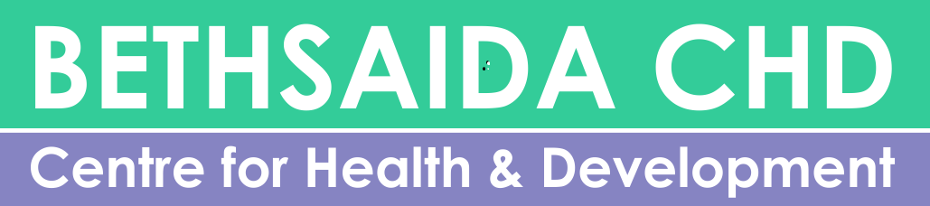

Bethsaida Health Centre, Musoma, Tanzania
Annual Report 2017
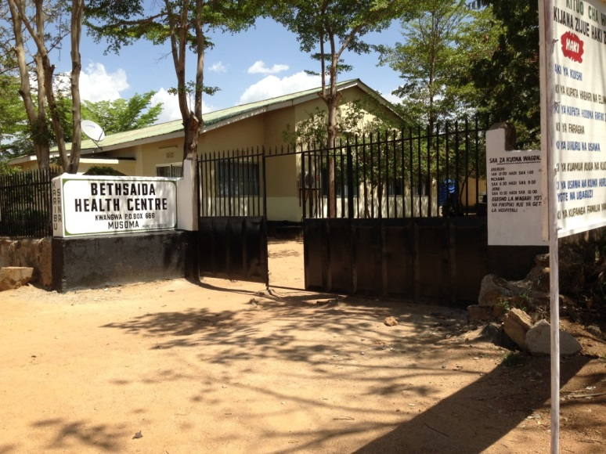

“Together we maintain Bethsaida”

AFRICA
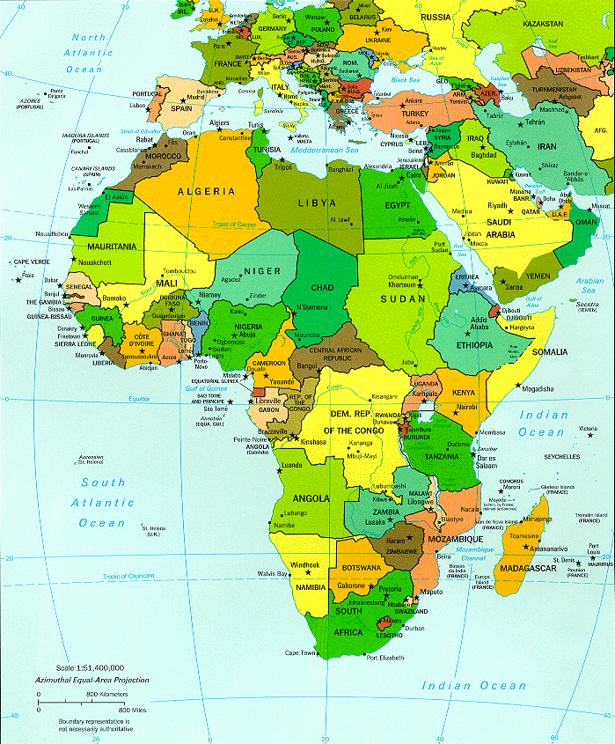

TANZANIA

TANZANIA - MUSOMA
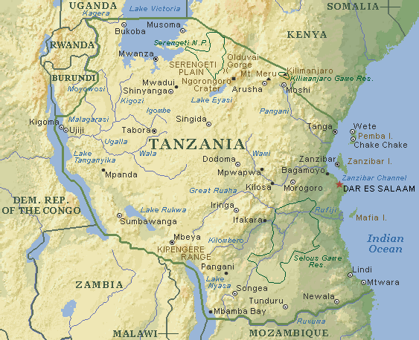
BETHSAIDA

CONTENT PAGE

- Introduction 4
- Mission and Strategy 4
- General goal
- Motivation and commitment
- Services 5
- Contact 5
- Bethsaida Organogram 6
- Bethsaida Organization 7
- Narrative Report 8
- Home Care and “ Running for Walking” 10
- Three new programs in Bethsaida 14
- Challenges 2017 15
- Donors 2017 16
- Special Visitors 17
- Top-ten diseases 18
- Population Statistics Mara Region 19
- Cooperation with other organizations 20

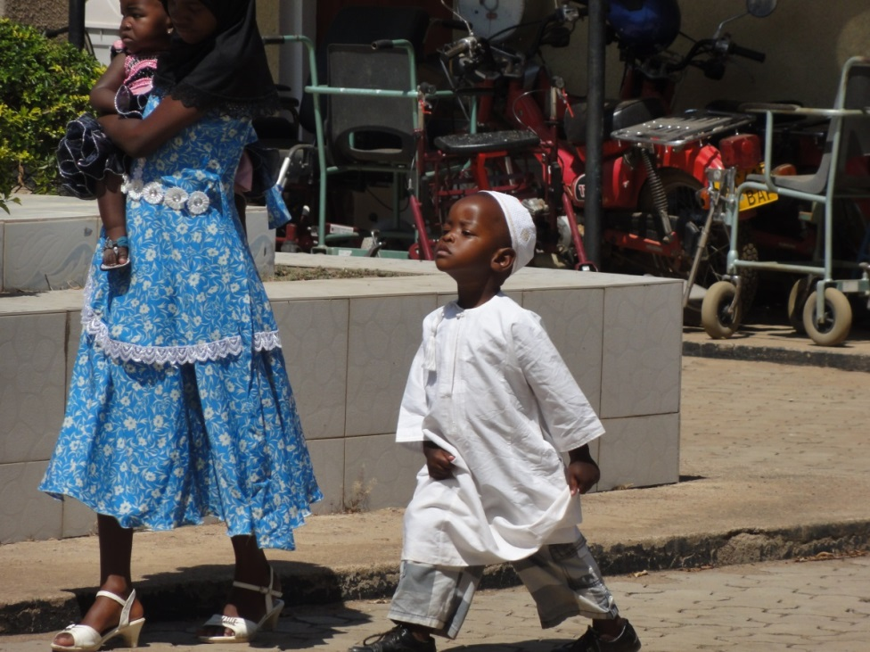

Coming to Bethsaida
- Introduction

Bethsaida CHD is a non profit Tanzanian registered organization (incorp. no. 60280) that operates a Health Centre with a Home Care Facility. The Health Centre offers both services at the center as well as at patients’ homes during visits in accordance with health and social welfare policy and health practitioner’s ethical standards.

2. Our mission and strategy
General goal:
We strive to offer services based on the Tanzanian Development Vision – 2025, her present Health Policy (2005) and in line with the Development Millennium Goals for 2015. Bethsaida CHD therefore envisages offering equitable accessible and effective health services to people in our service area with efficiency to improve health and livelihood.

Our motivation and commitment:
Acknowledging our Government resource limitations and realizing the availability of poor, disadvantaged and vulnerable groups among us, we are determined to offer quality health services to all through:
- Public-Private Partnership arrangement with our local Government Authority and collaboration with all other stakeholders.
- Principals of equity where we offer services not only at the center but also through a Community Home care Facility with a target exemption provision to unable to pay clients.
- Comprehensive and integrated approach by coordinating all activities in our strategic plans be it preventive, curative, rehabilitative, educative or health promotion in liaison with other health providers in the region.
- Quality Insurance Strategy where supervision, open performance appraisals and helpful client’s suggestions are considered.
- Our Working Philosophy: we cling to practical and efficient working that manifest integrity, innovation, effective use of resources and ethical consideration for holistic development of Mankind.
- Our Services through Home care: following the Tanzanian Ministry of Health and Social Welfare guidelines (2005) and upon arrangement, we can offer Home Care in accordance with the available resources as follows:
Medical- and nursing care, Counseling and Testing, Palliative Care including pain management , Ensuring patients medical adherence, psychological- and social support, nutritional guidance & food support, preventive – and health education, support equipment for disabled patients.

- Services we offer

Health services at the Centre.
Medical- and Nursing care, Contraceptive and Cervical Cancer screening, Ultrasounds and ECG’s, all laboratory investigations, Counseling & Testing, Palliative Care including Pain Management, Ensuring patients’ Medical Adherence, Psychological – and social support, Nutritional Guidance & Food Support, Preventive and Health Education, Support equipment for disabled patients.

Health services at home.
Bethsaida Health Centre offers Home care to everybody who is not able to come to the Centre. It is all inclusive care meaning there is no differentiation in the type of illness or disability a patient has.

4. Contact

Bethsaida Health Centre:

Office number: Tel. +255 786 235 626
In Charge: Mrs. Millicent Rabach
Adress: Chirangi Street, Kwangwa Area
P.O.Box 666, Musoma,Tanzania.

WEBSITE: WWW.BETHSAIDACHD.ORH

EMAIL: SEE WEBSITE
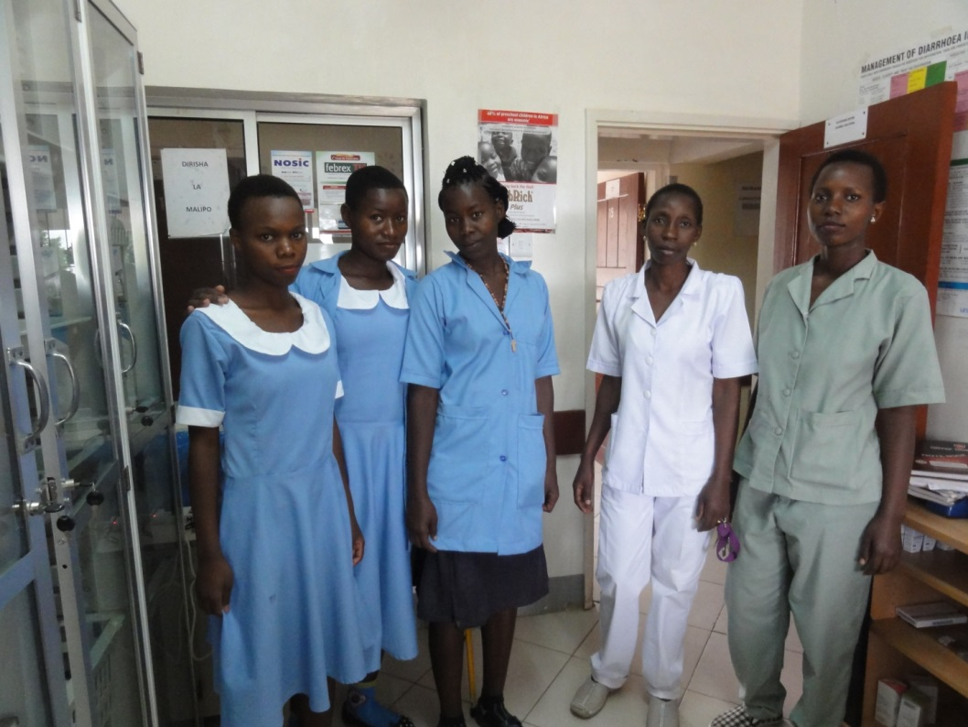

Students in blue uniforms are students from het Lake Victoria Disability Centre
5. ORGANOGRAM BETHSAIDA CENTRE FOR HEALTH AND DEVELOPMENT
Board of Directors

Medical Supervisor

Medical Superintendant
Management team

Medical Department
Medical Officer
Nursing Department
Nursing Officer
Administration Department
Public Health Department

AMO
CO
Laboratory
Pharmacy
Ultrasound
Physiotherapy
Occupational Therapy
Operation Theatre
Health Secretary
Accountant
ICT
Watchman
Driver
NO / ANO
Public Health Nurse
Enrolled Nurses
Medical Attendants
Cleaners
Laundry
Cleaners
Home Care
Research
Social worker
Outreach program

6. BETHSAIDA CENTRE FOR HEALTH AND DEVELOPMENT, THE ORGANIZATION

CO-DIRECTORS
Mr. Dr. Musuto Chirangi, Phd
Mr. Jumanne Magiri, MPH

Advisor to the board
Mrs. Elisabeth de Quant, BHA

MEDICAL SUPERVISOR
Dr. B.M. Chirangi MSc, MPH

MANAGEMENT TEAM
Dr. Byanza : Assistant Medical Officer (AMO)
Mrs. Millicent Rabach : Matron
Mr.Robert Mochomba : Accountant
Mr. Julius Nyassa : Lab Technologist

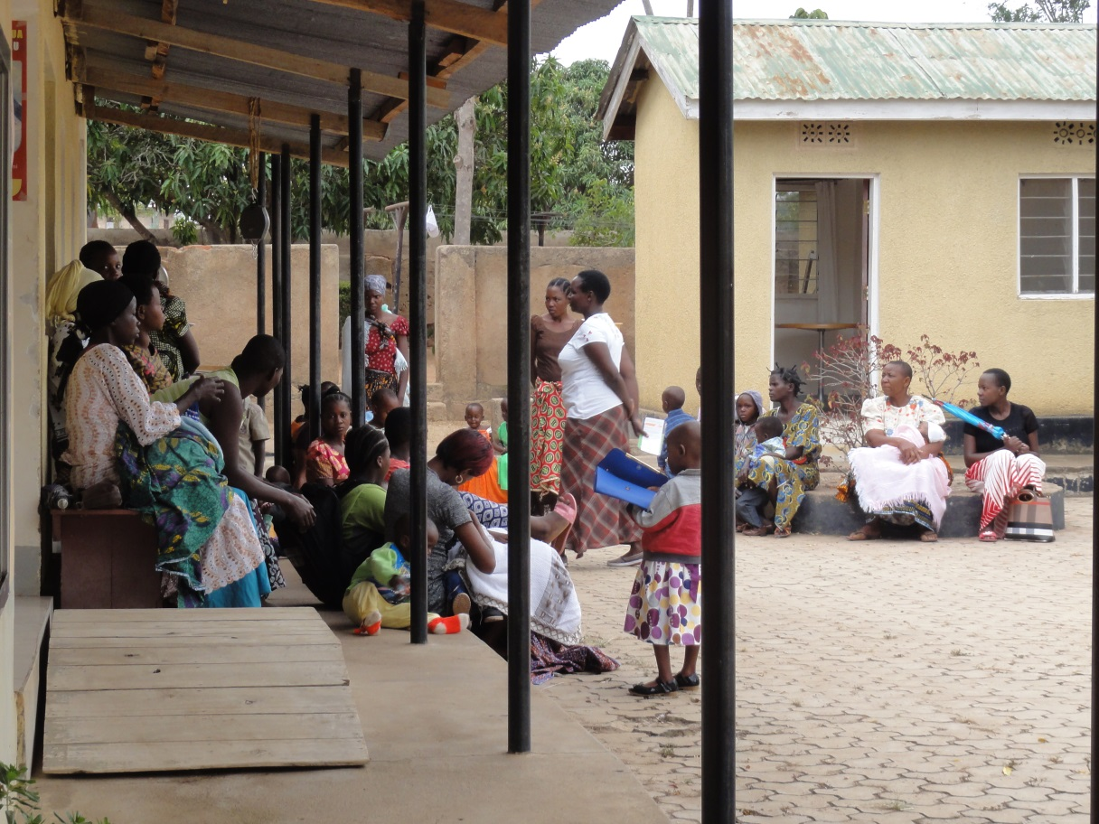
Every Monday and Friday Bethsaida gives Health Education on different topics to our clients and everybody who is interested

- Narrative Report about 2017

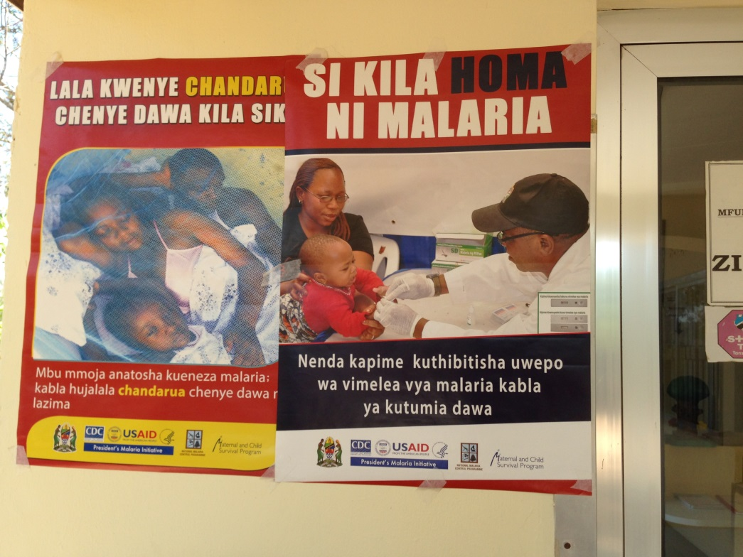

In our waiting hall: an educational poster about prevention and awareness of Malaria.

- For the PPP we asked, the interference of the District Commissioner of both Musoma town and urban. He failed also. Later on we found out through APHTA, the organization for Private Health Institutions, that no private institutions, either Hospitals, Health Centre’s or Dispensaries have a Public / Private Partnership (PPP) with the government.
- Millicent went out for outreach at Nyamatari area to look for new patients and to advertise that we do Cervical Cancer Sreening and Treatment and to advertise Bethsaida. She was accommodated by the Kamnyonge Church and she performed 96 procedures. These services were given for free but the advertisement for Bethsaida was good. At that following week the attendance to Bethsaida was very high.
- Every Monday and Friday Bethsaida gives health education on different topics to our clients and those who are there being our patients. Topics such as malaria, methods of family planning, waterborne diseases, hygiene, cervical cancer, albinism awareness, schistosomiasis, maternal care and preparation before birth giving. All of this is announced to the wall.
- Since February 2018 we have 5 students from : Lake Victoria Disability Centre, 3 ladies and 2 boys. They are studying for medical attendant and they are here for 2 months. The main aim is to get practice.
- There was a women who suffered from severe pain in her abdomen for 3 years and was admitted in the regional hospital. When she came to Bethsaida for Cervical Cancer screening Millicent advised her to see Dr. Bituro. He did do full examination. She also got an abdominal Ultrasound. She had an abdominal mass/tumor. She was referred back to the Regional hospital by Dr. Bituro for surgical intervention. She was very grateful to Bethsaida. Up to now she is doing fine.
- The accountant hears outside of Bethsaida that our services are good with reasonable prices. Our policy according to ethical standards is good.
- Hospital supervisors from local and central governments are always saying that Bethsaida is very clean compared to other Health Centre’s.
- There is a problem going on in the neighborhood that Bethsaida is expensive, which is not so if we compare our prices to other Private Health Centre’s.
- A problem is that people are getting poorer compared to the past and the gap between rich and poor people is becoming bigger.
- Bethsaida got another store for all kinds of supply. The present store is now only used for drugs.
- Bethsaida got a qualified lab technologist. This makes it possible to register the lab.
- PSI visited Bethsaida and they interviewed Millicent about family planning and long-terme contraceptives.
- Since last year Bethsaida has clean pipeline water from Spencon, a huge water clearance company in Musoma. We have now a water well (borehole), pipeline water and a rain harvesting system. This is very good for hygiene, for the patients, for the autoclave and the laundry machine.
- An amazing story is the following story: a life saved!
- Once the phone was ringing. It was a family some 10 minutes walking away. It was an emergency call. About the women who delivered her baby after being unconscious because of the long delivery. She woke up and in one push the baby came out with the placenta. When our nurse arrived she found a “dead “ looking baby on the floor, still with the cord to the placenta.
- She cut the cord and run back to Bethsaida with the baby. She, together with the Matron Millicent Rabach, resuscitated the baby and he started to breathe again.
- Later the mother came with the family; she was cleaned and taken care of. Than they lead the baby to her breast. It was difficult for the baby to drink but 24 hours later I saw them. The baby was drinking, alive and the mother was doing well again.

- Home care and “ Running for Walking” , the operation program for disabled children
From September 2016 up to January 2017 the Dutch occupational therapist Lidwien Weitenberg worked in Bethsaida Home Care and helped many patients. Also from the budget from Running for Walking, she helped Bethsaida to go with 4 children to see the orthopedic surgeon in Shirati Hospital. Three out of four children were operated and back on their feet again. One was not possible to operate due to significant contractions.
In September 2017 Sjoukje Wethmar and Elisabeth de Quant made a follow up. There are still children who can be helped with an operation. In the end of March 2018 the orthopedic surgeon comes back in Shirati
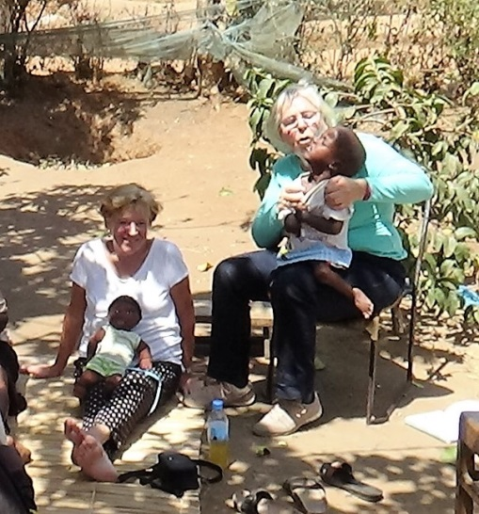
Home Care visits
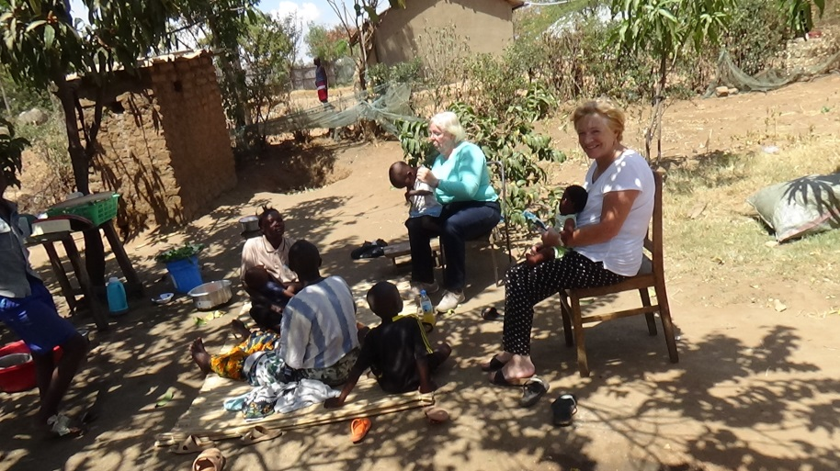

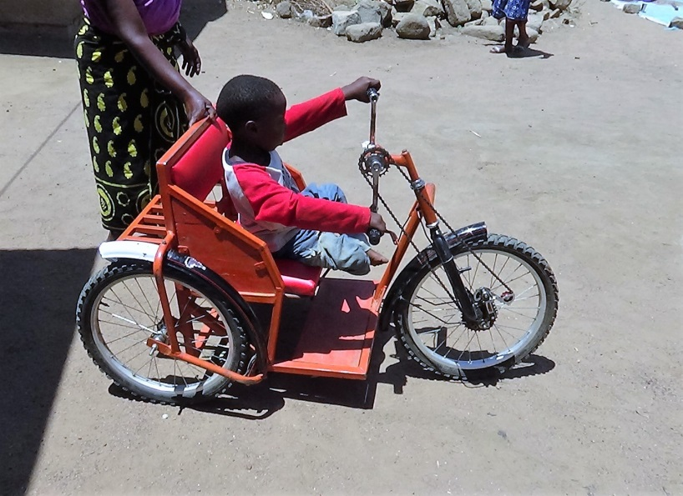
Wheelchair from Lake
Victoria Disability Centre

- We will go again with four or five children:

- Samuel Kiraka Shabani , 1 year Kigera, tel number: 0684030607
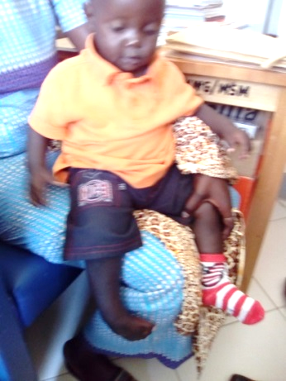
Clubfoot right side.

- Mwajita, 6 years
Contractures of the fingers.

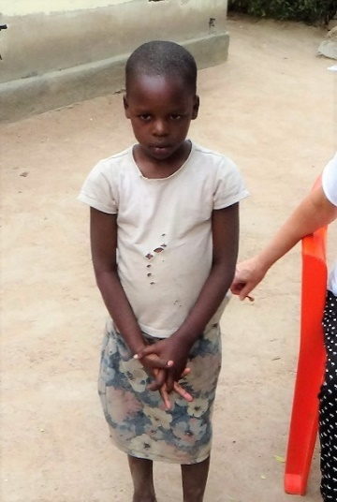
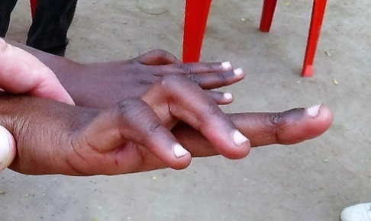
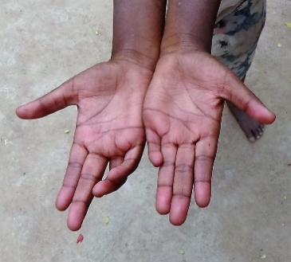

- Baraka Lameck Sonbe, 11 years, clubfeet., tel number 0799863969

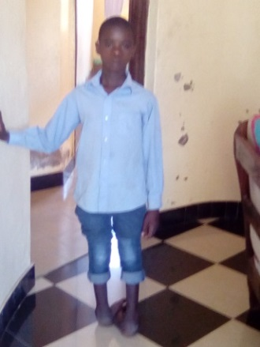
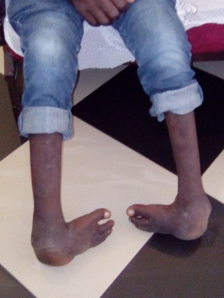

- Boy with clubfoot right side : Makunja Magesa , 11 YRS tel. 0788 386169

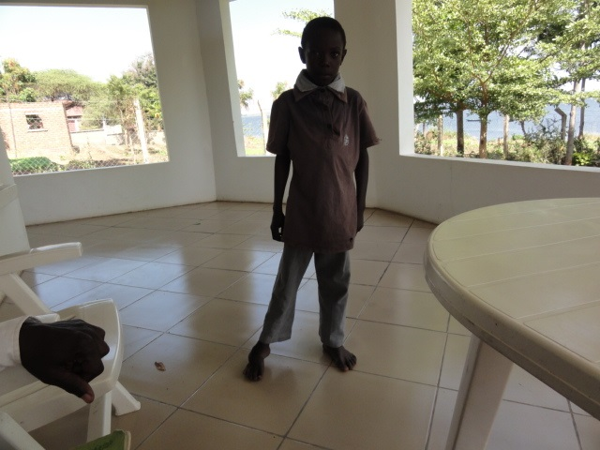

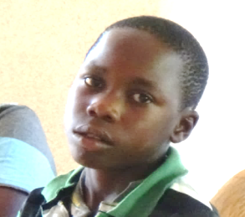
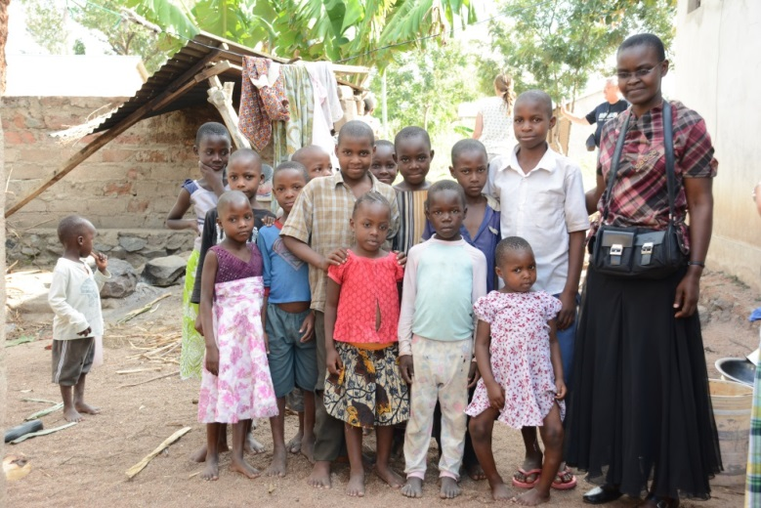
.

The girl with the bowed legs was operated. On the right side: Millicent Rabach.

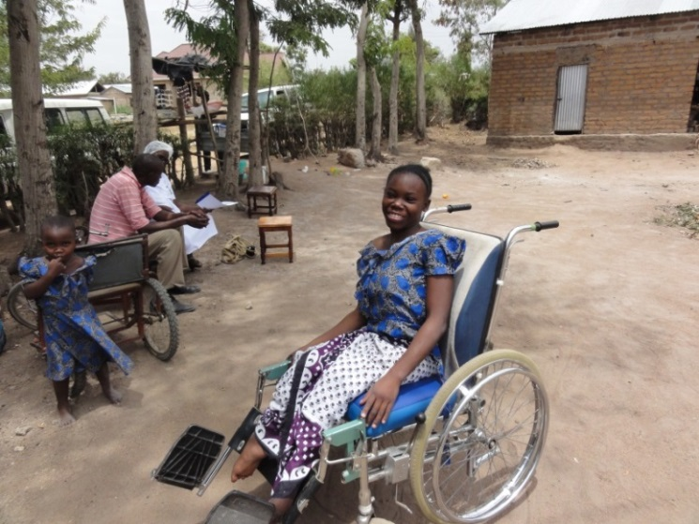

Rachel, paralyzed because of a Spina Bbifida, in her new wheelchair. She needed to sign for it because it is borrowed from Bethsaida. Rachel is a girl we follow now for about 8 years.

At peoples home; the boy left cannot keep his head up.
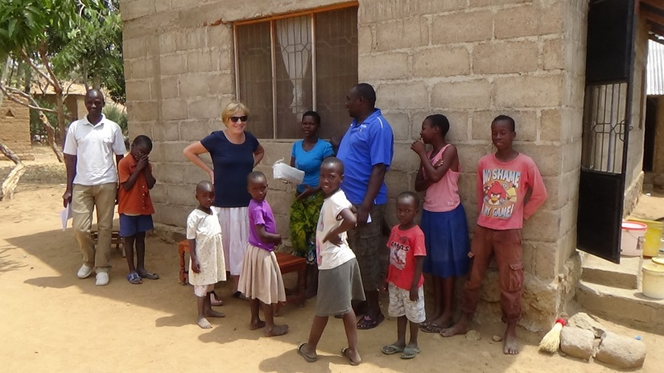

- Three new programs in Bethsaida

In Bethsaida there are implemented three new programs:

KMCT (Kenia, 3 persons,) for UBT training, Uterine Baloon Tamponade, treatment of postpartum bleedings.

2.
Peacemakers for Albinism for health education about Albinism to spread this knowledge in the area. Bethsaida treats them because of this knowledge in case they need medical treatment.

3.
Government program for teenagers: Youth Friendly Services
This program is to empower teenagers for their future.

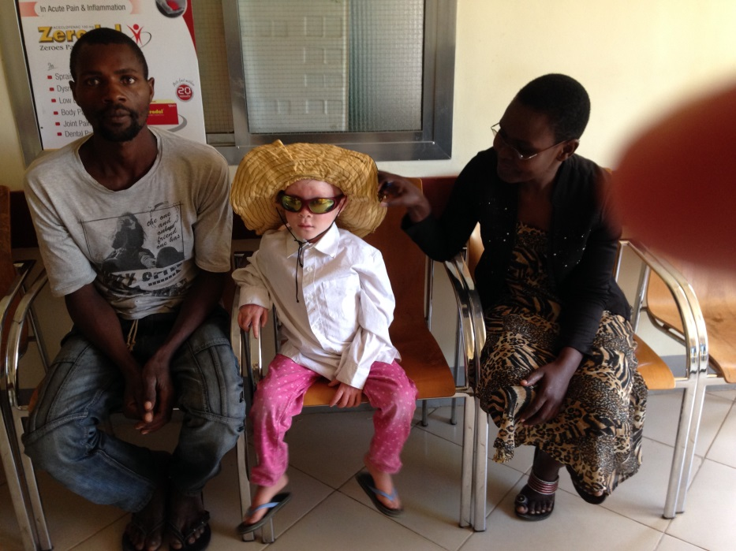

Albino Peace Maker Team
This albino girl has black parents who are looking for medical treatment for her because she already developed skin cancer. At this moment Bethsaida has more albino children; they are going to normal schools. The Albino Peace Maker team is supporting these children.

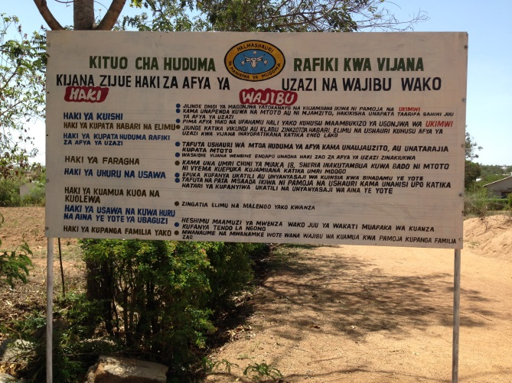

Youth Friendly Services.
This is a new program introduced and paid by the government. This service is given to teenagers who cannot fully express themselves, in order to create awareness. They should get to know that their presence is acknowledge in the community and at large. This program want them to fell themselves important for the community in order to express themselves . with all their problems and needs.
Bethsaida is waiting for the RMO and RNO to open this service. These teenagers will come from
secondary schools.
- Challenges 2017

- Open a CTC Department. This is for Counseling and Testing persons who might be HIF infected.
If we have room, this service will be established by the government.
- Dentist, this will come after the new rooms are finished. By that time there will be room inside of the main building.
- ECG machine and Cardio-echo-machine. For the use of the ECG machine and the Cardio-echo machine we will ask Mr. Rabach, retired biomedical engineer from Bugando Medical Centre, to come and do a training on the job in Bethsaida.
- Bethsaida did apply for a physiotherapist especially for Home Care and post-surgery patients from Inter Team, Switserland
- We plan to prepare Bethsaida to do all possible and allowed operations by dr. Biyanza, AMO and surgeon.

- Donors in 2017

Our donors in 2017 were:

Dutch Women Mission Organization, The Netherlands
Mennonite Foundation for Health Care, The Netherlands
Mennonite Congregation in The Netherlands:
- Ouddorp
- The Hague
- Hoofddorp
Gifts from individual persons in The Netherlands
Mare Fund, The Netherlands
Mennonite World Work, organization for solidarity and peace, The Netherlands
Protestant Churches of:
- Rijswijk
- Maastricht

We thank God and everybody who is willing to support Bethsaida.
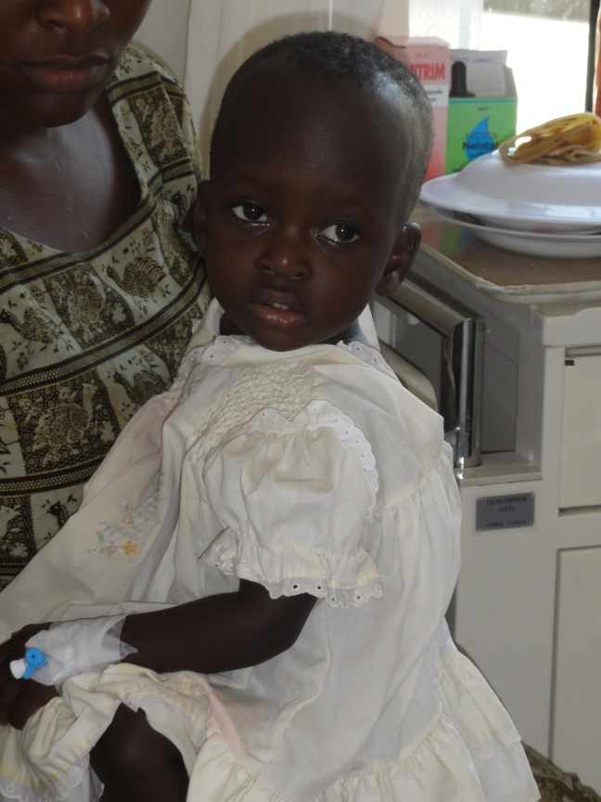

Your gift saves lives!
13: Special visitors

- MCC Tanzania visited us 1 time for a friendly visit, discussions and introduction of the new country coordinator. Also for their project about albino’s.
- Public Service International (PSI) Mara: they came 4 times (quarterly basis) for surpportive supervision about Servical Cancer screening and Contraceptive procedures.
- NSSF: 3x for discussions about payments.
- Salama pharmacy visited Bethsaida for discussions for procurement of drugs and advertisement of their products
- Philips pharmacy visited Bethsaida for discussions for procurement of drugs and advertisement of their products
- Haron & Company, for Audit reports 2013 and 2014.
- Government Dar es Salaam: for data collection
- NHIF Mara: they came 2 times.
- RHMC (Regional Health Management team – RNO Mara): 1x for supervision: for quality improvement and baseline assessment and for areas where we were told to improve
- Jipiego / USAid: 2 x for quality improvement and plan of action; they work with Nursing Departments; they do trainings on the job also.
- Musoma Municipal Trade Officer: dealing with matters of procurement.
- Manager of Health and Social Work from Dar es Salaam 2x for rapid assessment; the mark was average because of the amount of technical staff.
- Aids Relief: 2 x for assessment about having a CTC; they brought HIV test kids for free.
- Fire and Rescue Force: for supervision of our fire extinguishers they proposed that we should add two more;
- APHTA: they invited us about keeping good records. Also they organized a discussion about PPP agreements, mainly about RCH Departments in health Institutions. Assessment about Safe Care.
- Peacemakers for Albinism for health education about Albinism to spread this knowledge in the area. Bethsaida treats them because of this knowledge in case they need medical treatment.
- KMCT (Kenia, 3 persons,) for UBT training, Uterine Baloon Tamponade, treatment of postpartum bleedings.
- Lidwien Weitenberg. She worked as an occupational therapist for 5 months in Bethsaida Home Care. Later on her mother and brother also visited Bethsaida. She left in February 2017.
- The medical supervisor Dr.Chirangi came several times for supervision.
- PPP Coordinator Musoma, Yusuf G. Makena,
- District Nursing Officer, with a team for supervision.
- Leah Daniel for the Youth Friendly Services program.
- Tughe Mara Region, branche organization for workers, Allan Mihayo, visit
- TRA: about claim
- MMC, Musoma Municipal Counsel : they came to bring us a Certificate for Big Results Now (BRN)
- MMC: for Health Family Planning: He does sterilizations in Minor Theatre, 2x per year.
- Harley’s Tanzania, reagent, visiting for advertisement of their products.
- Mr. Ibrahim and Mr. Benedicto for construction work.
- Musoma Municipality: Aines: supervision of RCH.
- Drug and Food Authority: inspection of Drugs.
- Regional Commissioner and the Regional Medical Officer for PPP
- IPC: infection prevention Control, Mr. E. Honest. Came together with the PSI team.
- Inter Team, Anne Kuijs, for orientation in relation with an application for physiotherapist.

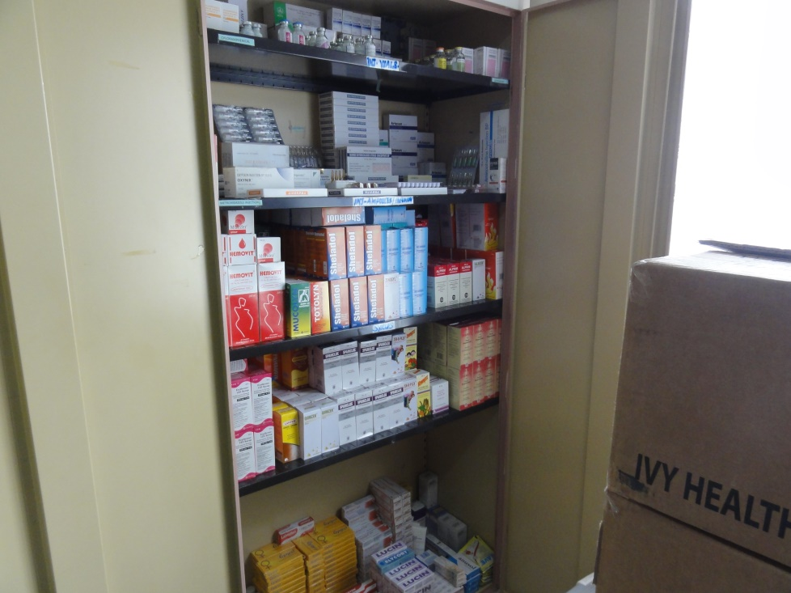

Besides laboratory reagent and other utensils, IV fluid, medical and nursing articles, it is very necessary to have always good and enough medication in stock for our pharmacy.

14: Top ten of common diseases

- Malaria
- Urine Tract Infection
- Diarrhea
- Schistomiasis
- Intestinal worms
- Ameba disssentary
- Anemia
- Clinical Aids
- Pneumonia
- Pelvic Inflammatory Disease

15. Population Statistics Mara Region from the Census of 2010
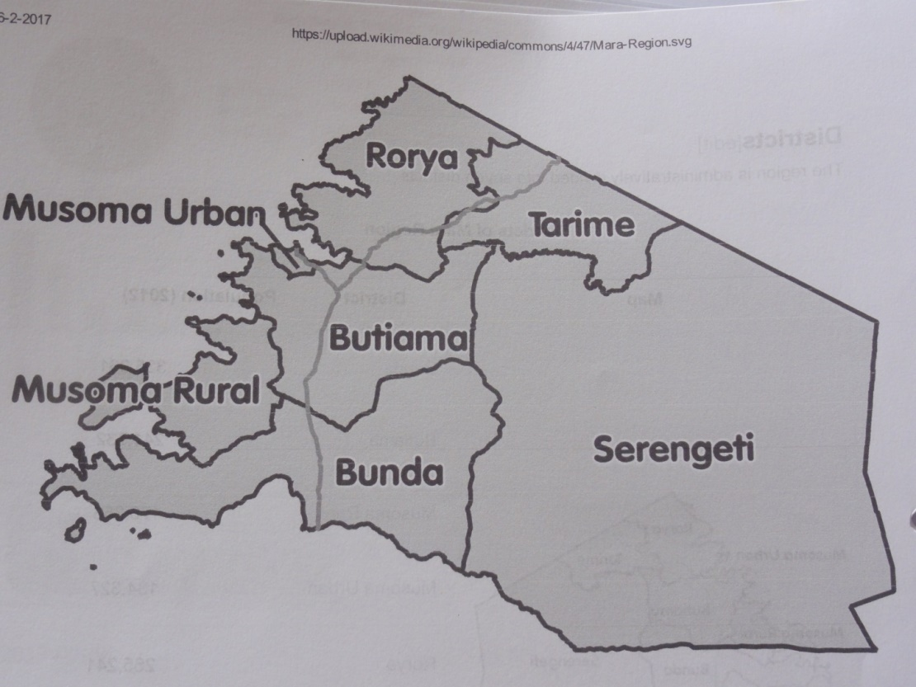

MARA Region
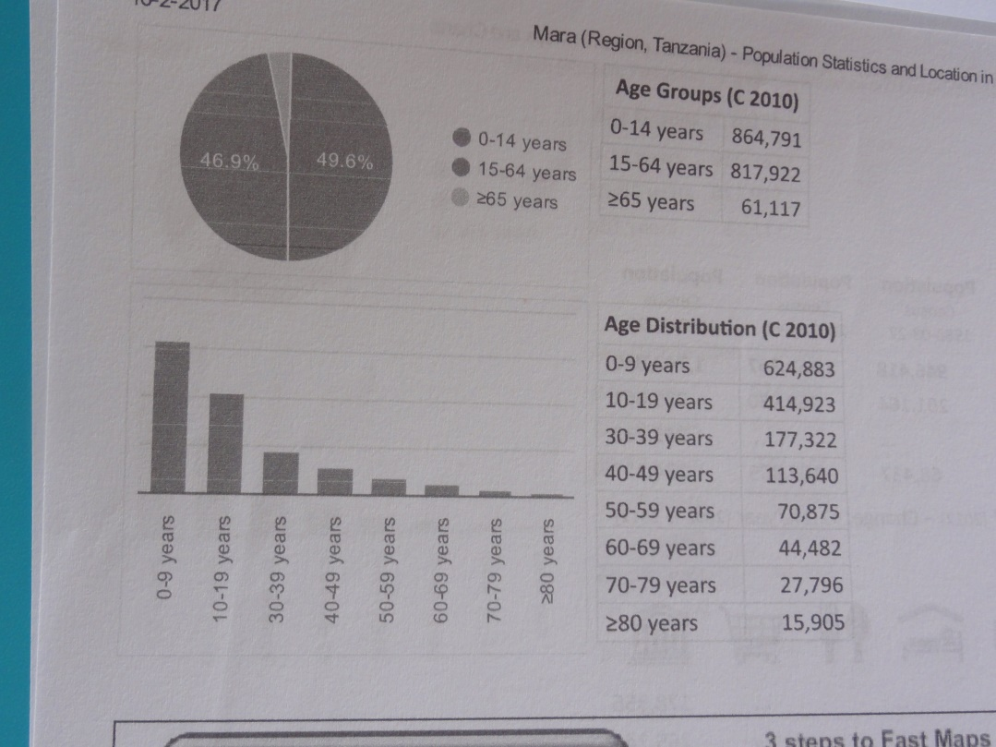

Age Groups (2010):
0-14 jaar: 864.791
15-64 jaar: 817.922
65 jaar en ouder: 61.117

16: Cooperation with other organizations
- MennonitischesHilfswerk (MH, Germany): payment of the research for Home Care.
- Doopsgezind WereldWerk (dgWW, The Netherlands): general support.
- Mennonite Central Committee (MCC, The United States / Canada): in different ways.
- Municipality of Musoma: paying the Reproductive Child health Care Department, provision of supportive supervision and baseline assessment.
- Public Service International (PSI): for Family Planning and seminars for workers. Through this organization Millicent Rabach, the Matron of Bethsaida was trained for giving services as Long Acting Reversible Contraception (LARC) and Cervical Cancer Screening.
- APHTA: Association for Private Health Sector in Tanzania: representing the Private Health Care sector towards the government for matters as the PPP. Furthermore they help with medical materials, they organize relevant seminars. From APHTA I learned that in the whole MARA region of which Musoma is the \capital, there is no Private Health \institution like Bethsaida which has a Public Private Partnership signed with the local Musoma Government. APHTA organized many meetings with this local government and their members but up to today There was no concrete result.
- NHIF: this is the National Health Insurance Fund. We have a contract with them. 45% of all our patients are under NHIF.
- NBC Bank: we discuss with them to get the opportunity for workers to get a loan.
- Anglican Church. They work on Home Care for HIV/Aids patients and when necessary they always bring their patients to Bethsaida.
- Musoma Referral Hospital, in all kind of ways.
- DMO, Dr. Honoratha, Regional Medical Officer (Mara).
- DNO, Mrs Nurath Hassan, District Nursing Officer (Musoma).
- RNO, Regional Nursing Officer (Mara). Mrs. Francis Mwanisi
- Lake Victoria Disability Centre, Musoma

